|  |  |
| --- | --- |
| **Year 11 Essentials** 2019 Test 4Perimeter, Area, Mass, Volume and CapacityResources allowed: Calculator and 1 x A4 page one side Name: ________________ | |
| Show all working out for full marks | Total: /45  Time: 45 mins |

1. **[6 marks]**

Convert the following

|  |  |
| --- | --- |
| 1. 56cm =___________mm 2. 3600m= __________km 3. 3.4= ___________ | 1. 500ml=______l 2. 634=_______ml 3. 580g=_________kg |

1. **[2 Marks]**

If you have a 2.5m piece of wood, and you needed 6 pieces cut, **estimate** how long should each piece be? (nearest 10cm)

1. **[3 marks]**

If a room is 7.2 metres long, and 5.9 meters wide, **estimate** how big is the room is to the nearest square meter? *(hint- draw a diagram and don’t give exact answer)*

1. **[2 marks]**

Find the perimeter of the following shapes

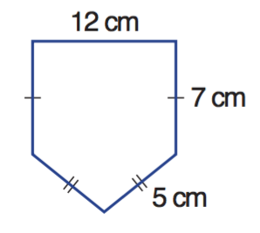

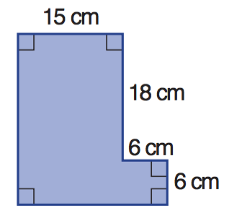a b

P =____________________ P =____________________

1. **[8 marks]**

Use the following table to convert these imperial units to metric

|  |  |
| --- | --- |
| **IMPERIAL** | **METRIC** |
| 1 inch | 2.54cm |
| 1 foot | 30.4cm |
| 1 yard | 91.44cm |
| 1 mile | 1.609km |

1. 40 feet to meters
2. 30 inches to centimetres
3. 65 metres to yards
4. 60 miles to Kilometres
5. **[7 marks]**

Find the Area of the following

|  |  |
| --- | --- |
|  |  |
|  |  |

1. **[5 marks]**

Jack is tiling his bathroom floor with 12cm by 12 cm tiles.

|  |  |
| --- | --- |
| 1. Find the area of floor that needs to be tiled 2. Find the area of each tile 3. How many tiles will Jack need to tile the bathroom? |  |

1. **[4 marks]**

25L of water is poured into a rectangular fish tank, which is 50cm long, 20cm wide and 20cm high. Will it overflow?

1. **[2 marks]**

A pack of 500 sheets of paper has a mass of 2.5kg. find the mass of one sheet of paper, giving your answer in the most appropriate unit.

1. **[6 marks]**

A farmer is building a fence around his horse paddock. The paddock has an area of 2 hectares.

1. If the length of the paddock is 125m, what is the width?
2. What length of fencing will be required to fence the entire horse paddock?
3. If the fencing costs $6/m, how much will it cost to fence the paddock?

**End of test**